1. Define energy. - | The ability to do work
2. Define kinetic energy. (page 241) | The energy of motion.
3. Define potential energy. (page 242) | Stored energy or energy of position.
4. What 2 factors affect potential energy? | Mass and Height
5. What 2 factors affect kinetic energy? | -Mass and Speed/Velocity
6. Define the seven forms of energy and give an example of each (pages 244 – 246)
Thermal energy  Energy due to random motion of particles  Example: ice-cold lemonade | Sound energy  Energy from vibrations.  Example: singing a song | Nuclear energy (2 types)  Energy that is stored in the nucleus.  Fusion – combining nuclei  Example: the sun  Fission – splitting nucleus  Example: Nuclear power plants
Chemical energy  Energy stored in the bonds of molecules  Examples: Batteries, fuel, food | Electromagnetic energy  Moving electromagnetic waves that can travel through empty space.  Examples: light, microwaves, UV light, radio, phone & TV signals.
Electrical energy  Energy due to moving charges (electrons).  Example: charging your iPad | Mechanical energy  The total energy of  Potential Energy + Kinetic Energy  Example: juggling
7. What type of energy is always produced in any energy conversion and why (p.256)
Thermal energy is always produced as a byproduct of an energy conversion.

8. Draw a roller coaster and label where the roller coaster has the most potential and most kinetic and explain why.
(p. 254)

9. State the law of conservation of energy (p.255)
Energy cannot be created or destroyed, only changed. The total amount of energy stays the same.

10. How do the energy conversions in a toaster reflect the law of conservation of energy? What happens to the total amount of energy in the system?
The law of conservation of energy is reflected in the toaster energy conversion because the total amount of energy stays the same throughout the conversion. The primary energy is electrical. Electrical partially converts to Thermal, Sound, and Electromagnetic (light) energies. All of the energies total to 100% throughout the conversion.

11. Identify the energy conversions in the following. Draw a diagram and then list which energy comes first.
Example | Picture | Sequence of Energy Forms
A. Oven | 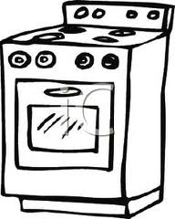 | electrical, thermal, electromagnetic
B. Car | 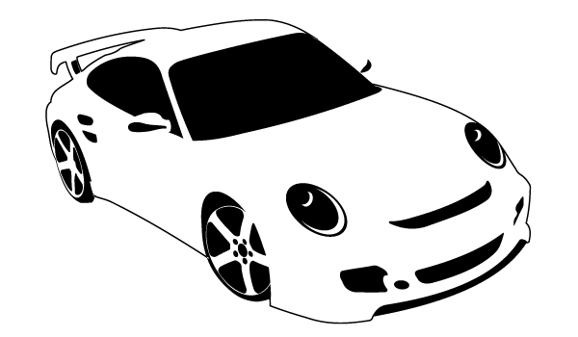 | chemical, thermal, electrical, mechanical, sound, electromagnetic
C. Person Swimming | 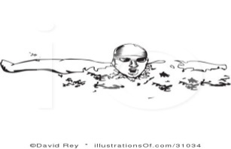 | chemical, mechanical, thermal, sound
D. DVD Player | 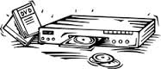 | electrical, mechanical, electromagnetic, thermal
12. Draw and label the three temperature scales in the space below.
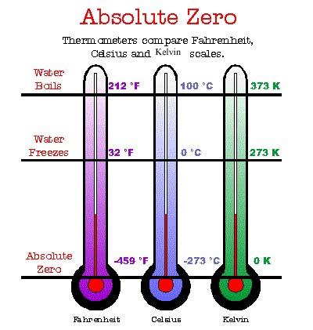

13. What is heat and how does heat flow?
Heat is thermal energy that is transferred from a warmer object to a colder object.

14. In the table below, define conduction, convection and radiation and give 3 real-life examples of each.
CONDUCTION | CONVECTION | RADIATION
Energy transferred by direct contact.  As a solid heats, the particles vibrate, these vibrations make the adjacent particles vibrate, and so on and so on, the vibrations are passed along the metal and so is the heat.  This is accomplished via kinetic energy.  Metals are good conductors of heat.  Real Life Examples of Conduction:  Heat transfer from the bottom of a hot pot to the handle.  Cooling red-hot metal by dipping it in water.  Using a fan to cool off our skin. | Energy transferred through liquids and gases.  Convection Current: When particles are heated, they spread out and become less dense. As this happens, the heated fluid rises and the cooler, denser fluid flows downward.  Real Life Examples of Convection:  Boiling water: Hot water on the bottom rises, cools at the surface, and sinks to the bottom.  Cooking in an oven.  Windy weather at the beach: The land is warmer than the sea. As the warm air rises the colder air from the sea moves in to take the place of the warm air that has risen. | Energy transferred by electromagnetic waves such as light, microwaves, and infrared radiation.  Radiation can be transferred without solids, liquids, or gases; can be transferred through empty space.  Real Life Examples of Radiation:  The sun warming Earth.  Cooking food in the microwave.  Feeling the heat put off of a fire from a few meters away.

